**Examples**

1. Create a Car class with the following properties - Make, Model, Current Speed, Engine Size. Use long hand properties, with private attributes and getters and setters. Make use of this. Create two objects and display details on the cars.
2. Add methods to display car information and another to Speed up car. Make use of these methods in your program.
3. Create a class called Bank Account with the following properties – Account Number, Account Holder, Balance. Create two bank account objects and display the bank details in your program.
4. Add methods to deposit and withdraw money from the bank accounts and make use of these methods in your program.

**Exercises**

1. Create an application named TestFlight that instantiates and displays a Flight object. The Flight class contains fields for an airline name (a string), flight number (an integer), row (an integer), and seat (a single letter).

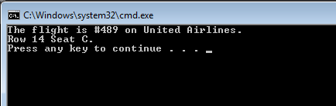

1. Create an application named TestCashRegister that instantiates and displays a CashRegister object. The CashRegister class contains a field for a total (a decimal) and a field for the number of items (an integer). The CashRegister class has a method called AddItem that takes in a price, adds it to the total and increments the number of items. The class includes read-only properties to get a Cash Registers total cash price and number of items. Create several CashRegister objects, add a number of items to each and print out the total price and number of items per cash register.

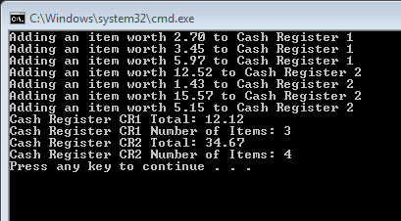

1. 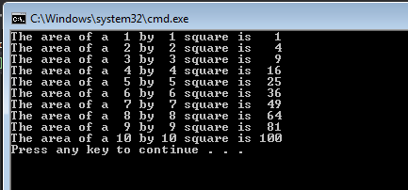Create a program named DemoSquares that instantiates an array of 10 Square objects with sides that have values of 1 through 10 and that displays the values for each Square. The Square class contains fields for area and the length of a side, and a constructor that requires a parameter for the length of one side of a Square. The constructor assigns its parameter to the length of the Square’s side field and calls a private method that computes the area field. Also include read-only properties to get a Square’s side and area.